Claim Credit-Live or Live-Virtual Activity
To claim credit for a live or live-virtual activity, you must be registered and marked as attended. The evaluation required to claim credit must be completed by the posted due date.
Via Computer
Step 1: Go to: https://jefferson-lehigh.cloud-cme.com
Step 2: Click Sign In on the top left using your email address and password.
Step 3: Click the My CME on the right side of the screen along the tabs.
Step 4:
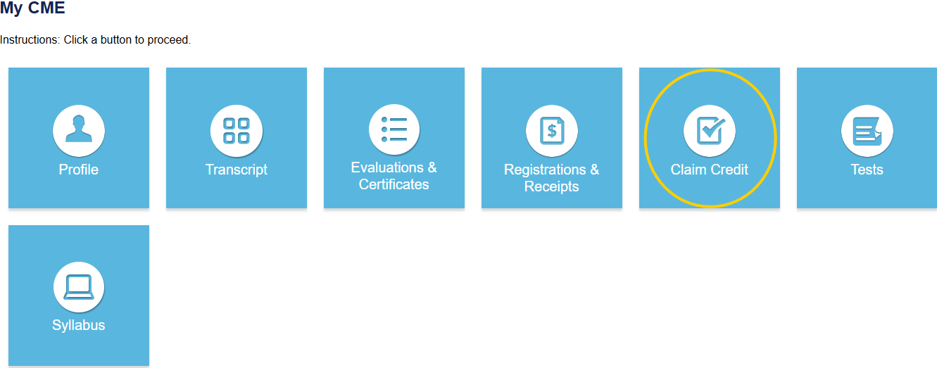
Step 5: Enter the Activity ID and click the Submit Activity ID button.
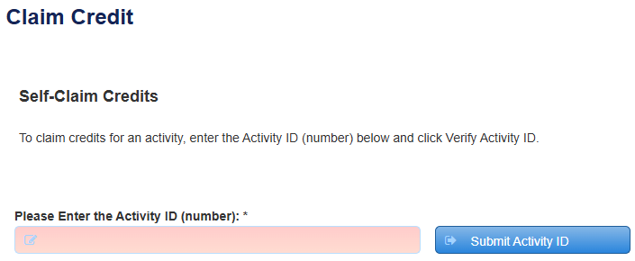
Step 6: Complete any additional questions or fields.
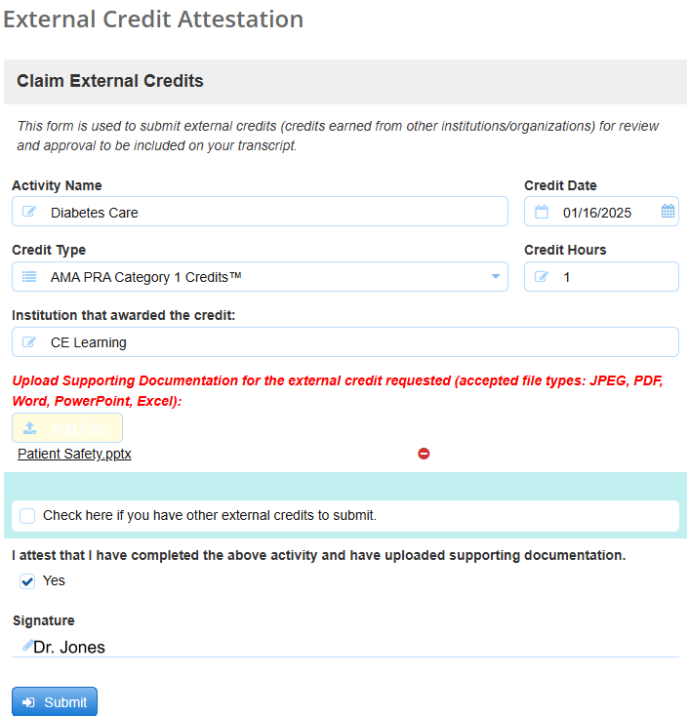

Via CloudCME Mobile App
In your browser search CloudCME® check in or CloudCME® mobile app and download to your Apple or Android device(s) to access the Check-in menu and scan a QR code. This app also features mobile access to your transcripts, access to the calendar of events, and many other exciting features!

How to Check In for
Grand Rounds, Case Conference, and/or Live activities:

1. Via mobile app – in your browser search CloudCME® check in or CloudCME® mobile app and download to your Apple or Android device(s) to access the Check-in menu and scan a QR code. This app also features mobile access to your transcripts, access to the calendar of events, and many other exciting features!

2. Via text message – A distinct code will be provided for each Grand Rounds, Case Conference, and/or Live activities.
If this is the first time you are texting your attendance, you must first pair your mobile number to your account. Text your email address to: (888) 352-5547 to opt-in to the text message attendance program. You will receive a text notification indicating your phone number has been updated. Once your account is paired to your mobile number and you have obtained the event code, send the code via text to: (888) 352-5547.

Please note, attendance can only be recorded 60 mins. prior to the activity start time, during the activity and up to 120 minutes after the activity closes.

